**Linux:**

Ad hoc:

The term "ad-hoc" means "for a specific purpose" or "as needed."

Ad-hoc commands are not pre-planned or written in reusable playbooks; they are used when a specific task arises that doesn't justify creating a full playbook

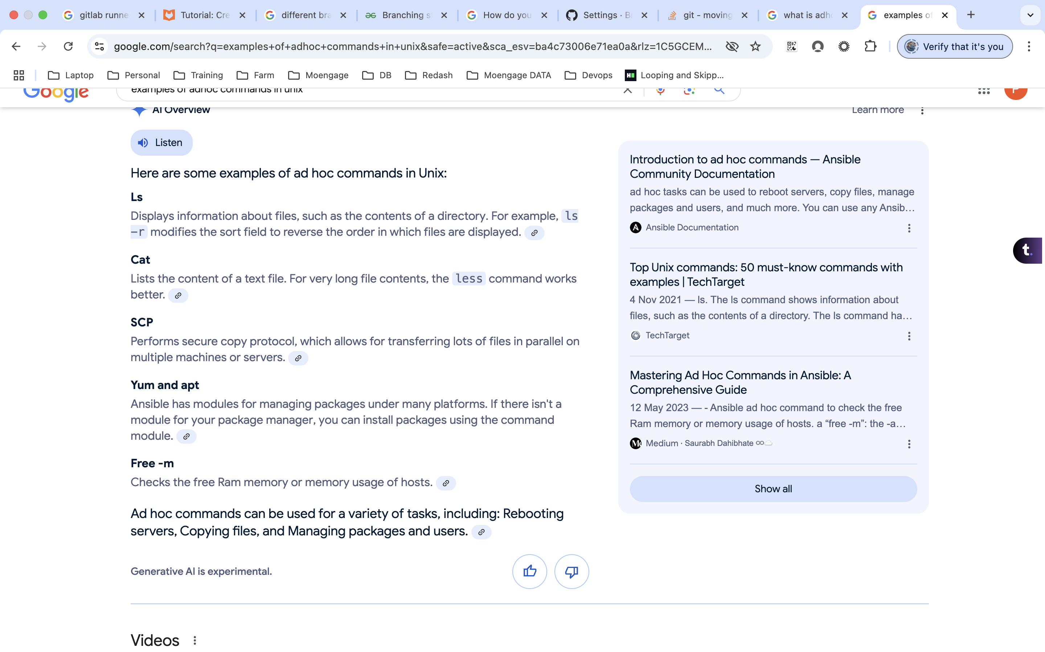

ask sudo pass:

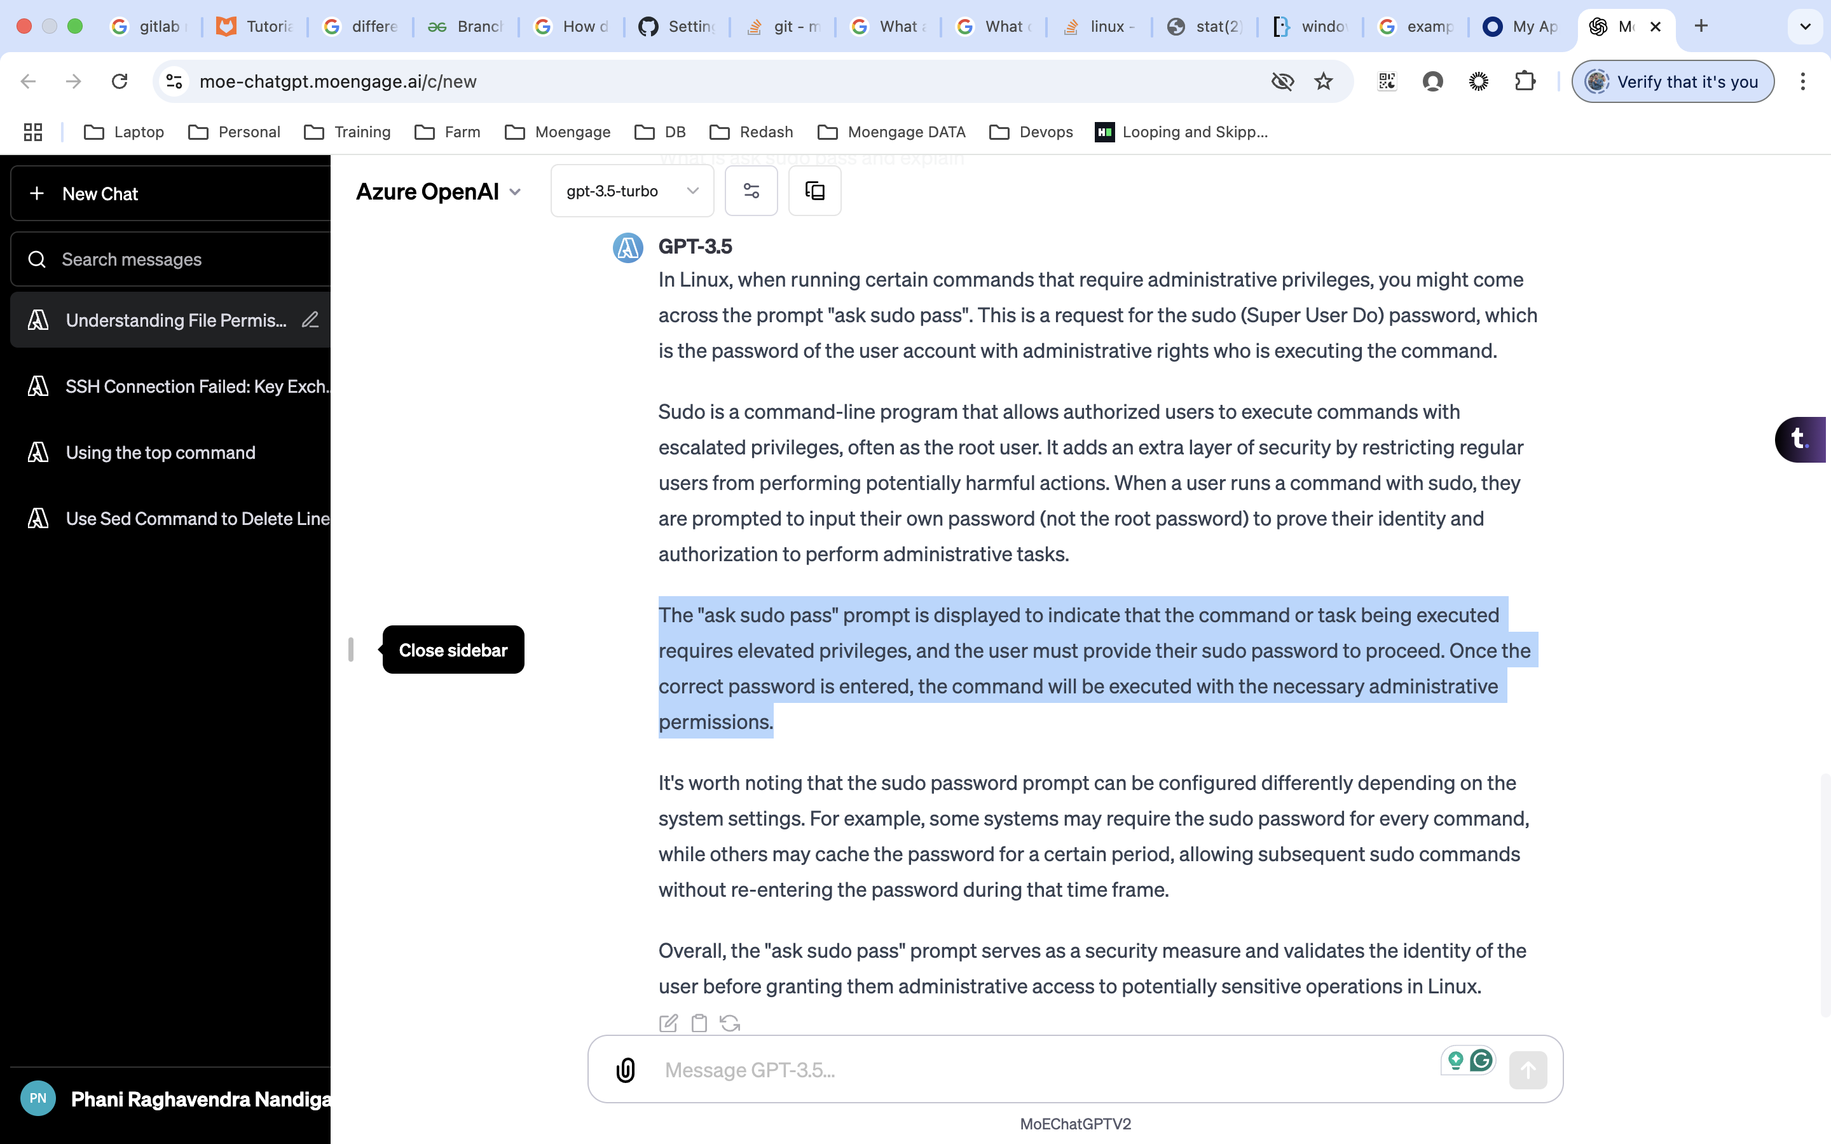

debug logs:

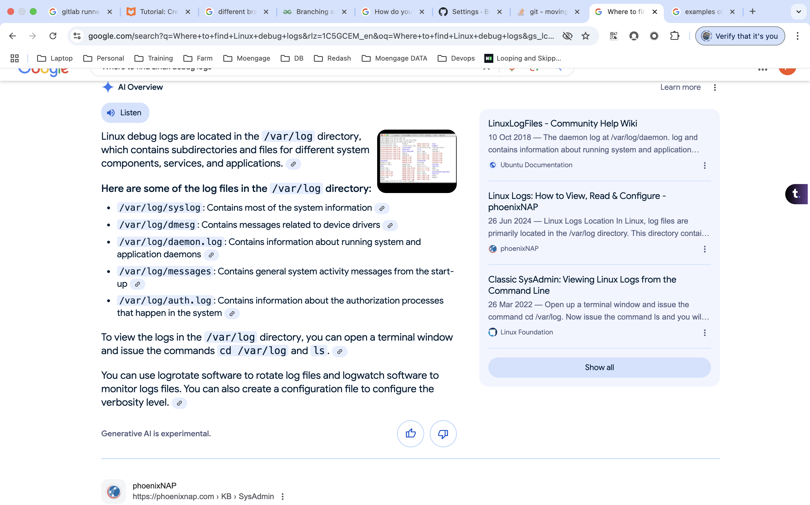

SID & GID:

**Per[**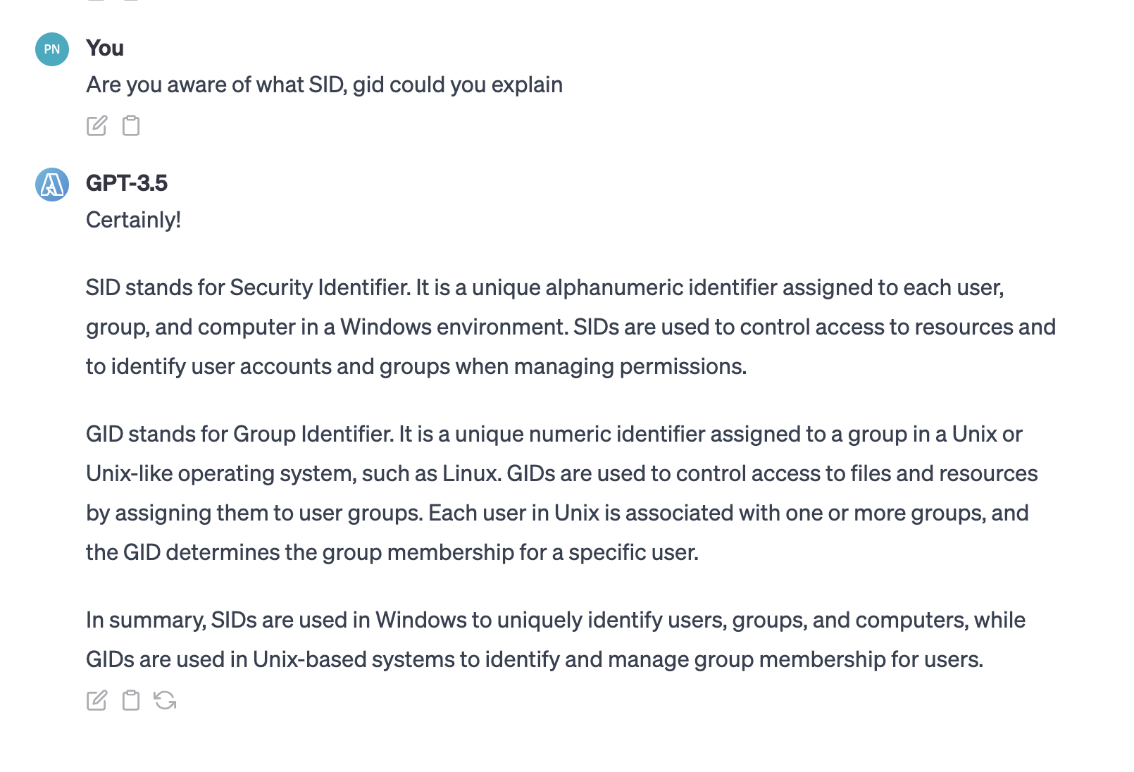

Performance:

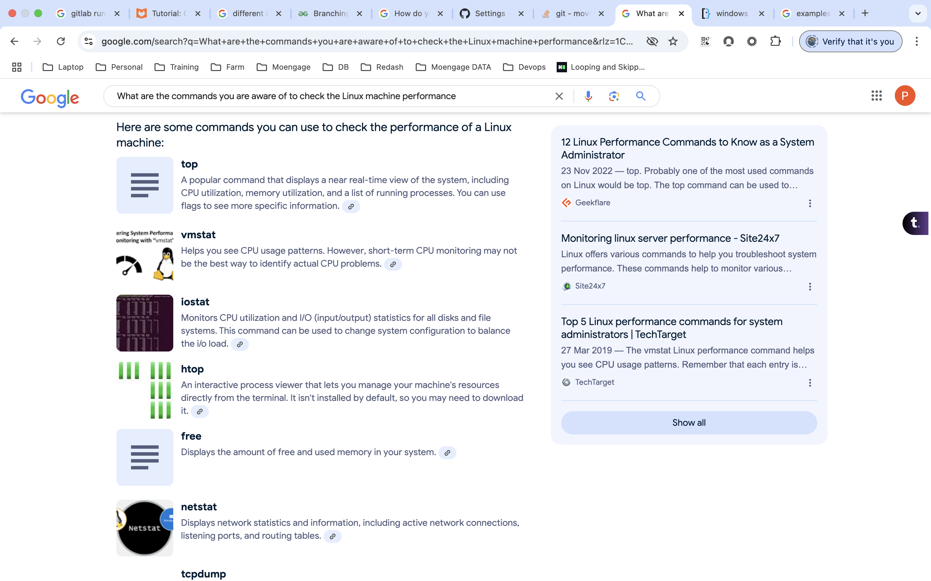

Jenkins server:

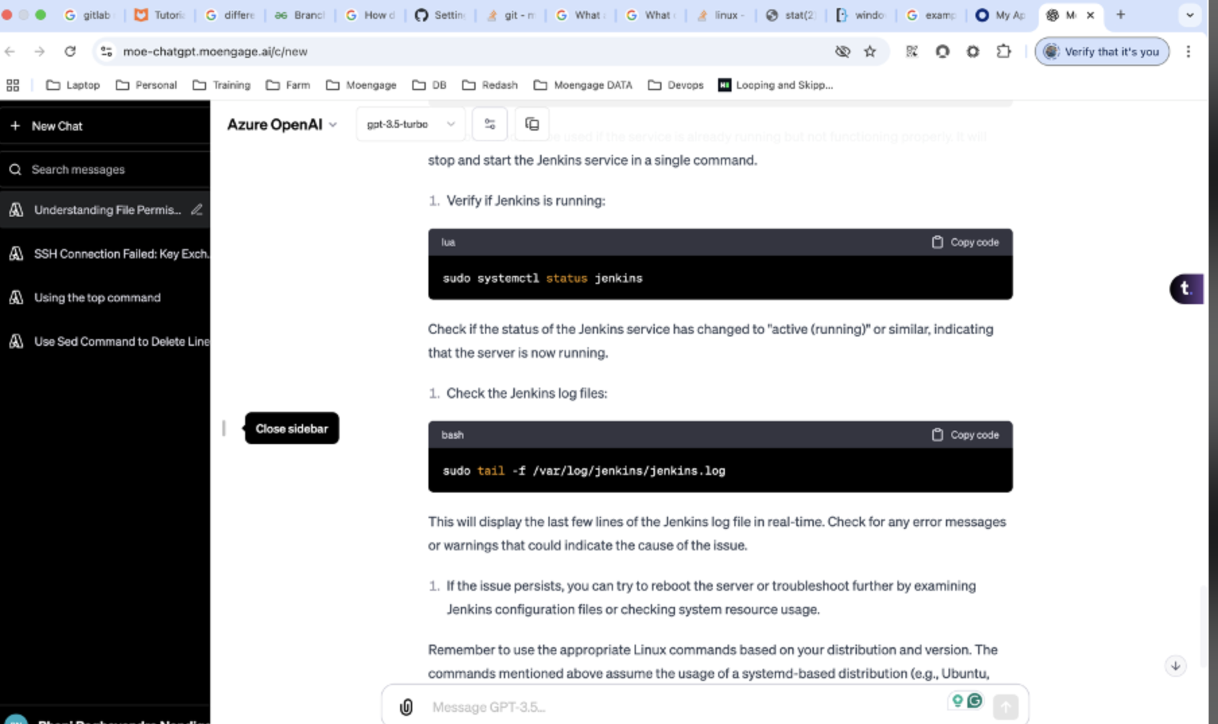

cronjob:

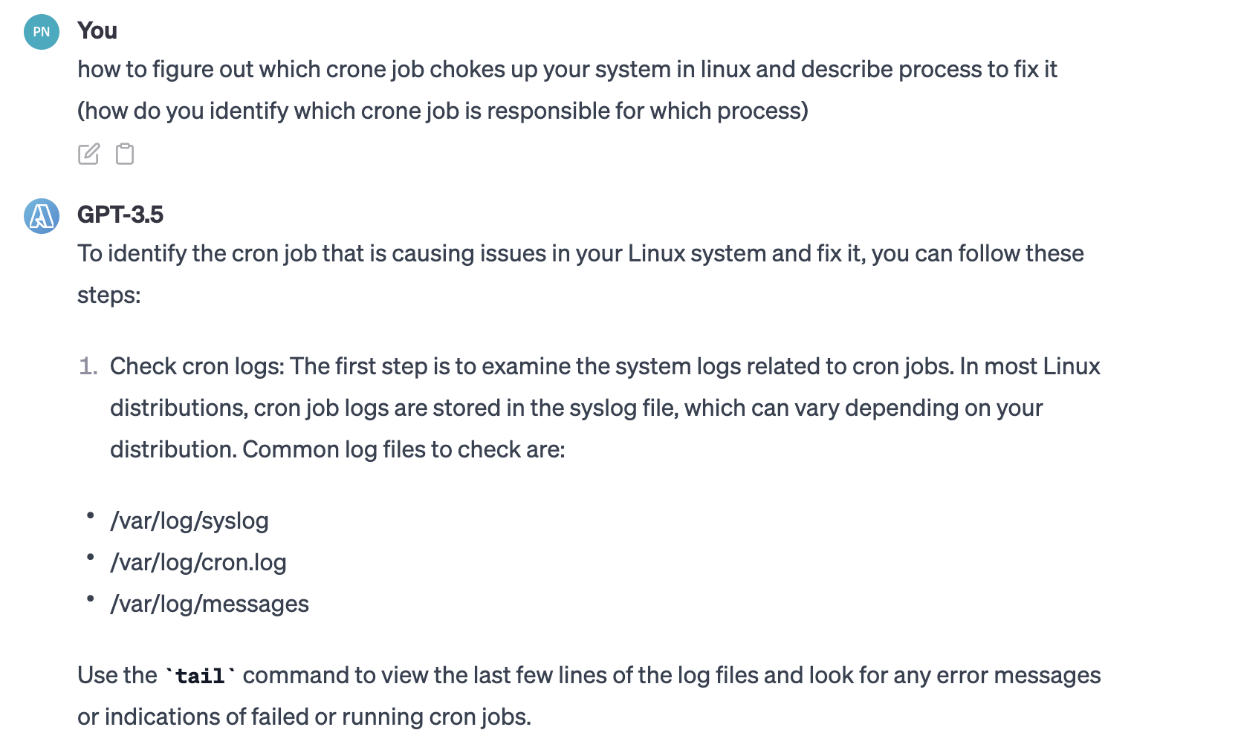

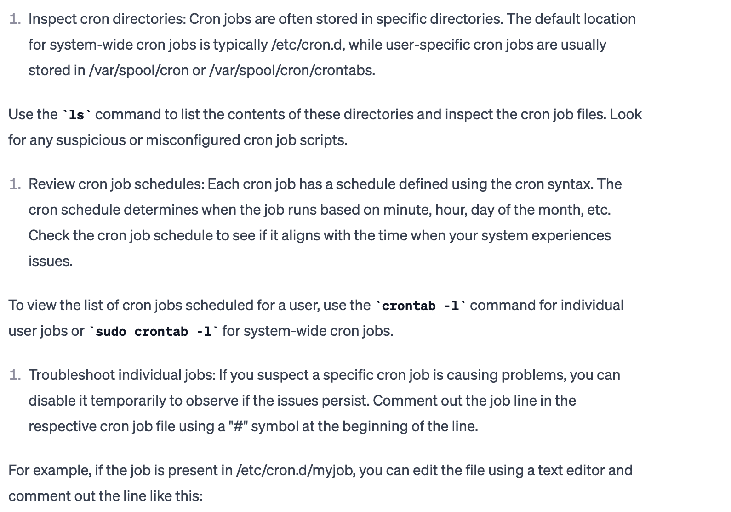

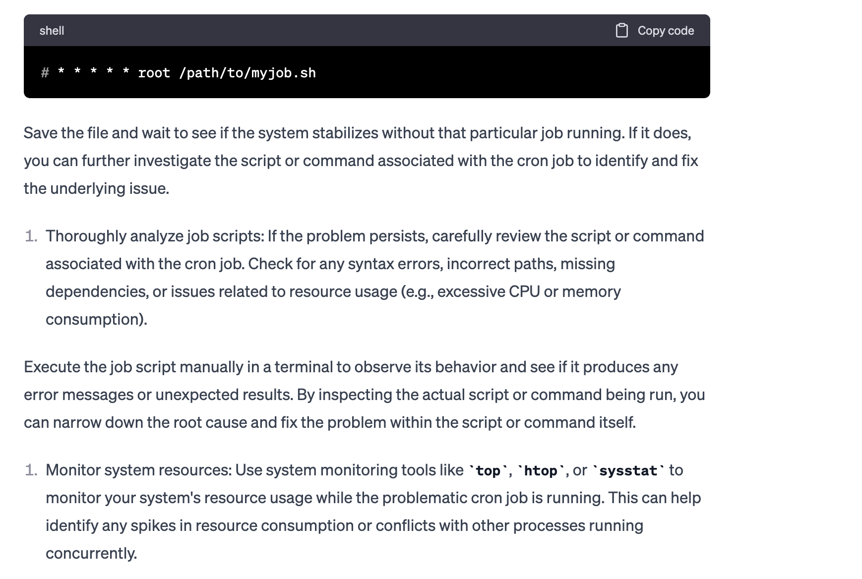

Mounting:

